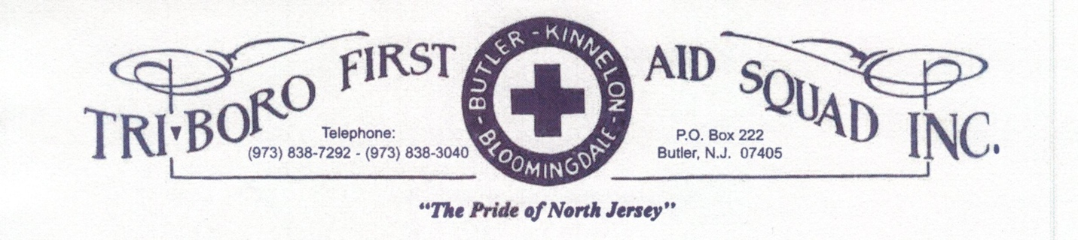

TBFAS Meeting Minutes
Date: 12/13/2022
Meeting was called to order at 19:34 by Gayle Dunlap, President with a salute to the flag followed by an inspirational saying by Anish Kuriachen. Roll call taken by Mary Hall. Motion to accept minutes by Hazel Whitty, seconded by John Futcher, motion carried.
Treasurer’s Report: Joyce Reyes
Beginning Balance: 67,440.14
Deposits: 44,257.00
Expenses: 26,176.67
Balance: 85,520.47
Fund Drive to Date: 17,308.68

Gold Cross: Dee Dunlap-Dean: did not attend November meeting and there is no meeting in December.
Health & Welfare: Leslie Graf: flowers sent to the wake of Justin Hill’s father; Dave Shimmel’s family sent an email to Dee thanking the squad for the fruit.
Special Events: Patti Tabler: invitations were put in everyone’s mailboxes, when completed please put them in Hazel Whitty or Leslie Graff’s mailbox.
Loan Outs: Michael Johnston: no report
Teen Squad: Patti Tabler: recharter, lost some members to college, 1 new coming on and 1 to adult squad
By Laws: Linda McKnight: Holidays interrupted the committee from meeting, will meet in January and some changes to be presented soon.
Publicity: Buzz Warren: no report
Refreshments: Amanda LoCicero: thank you Amanda & crew, new caterer for tonight’s dinner.
Uniforms: Alysha Futcher: quote for stock of uniforms, duty and yellow, 10 of each in stock, $2200 quoted. Baseball hats, show of hands most people wanted adjustable ball caps and also ordering winter hats.
Radios: John Futcher: one pager tonight to proby
I & G: Dee Dunlap-Dean: Austin will be coming on tonight and is a proby.
Oxygen: George Chernetz: no report
Membership: Dee Dunlap Dean: no report
Building & Grounds: Dean Marletta: took care of the bees, all sprayed, last yearly treatment for grounds, finalizing the deck, old manager is back at Lowes, talked to him, will finalize soon.

Ways & Means: Patti Tabler: Annette Vanderhoff reported that through social media only on Giving Tuesday we made about $1700.00
Insurance: Skip Mullin: no report
Health & Safety: George Chernetz: no report
Ad Hoc Tablets: Patti Tabler: have tablets, sheet to log people on, everyone gets a user name, you have your own password. See Patti to give your details needed to get set up. Will run a couple training nights to learn how to use.
Ad Hoc Rig: Mary Hall: no report
Captain’s Report: John Futcher: heaters in 2nd bay Dean will check.
1885 call as of 11/30, highest in the past was 1605. Total Nov calls 161; Mo Co took 51; TriBoro was paged for 110 and took 87 for 79%; 11 mutual aid calls; 2 Wanaque, 5 Ringwood, 1 Hardyston, 1 Lincoln Park, 1 Riverdale, 1 Pompton Lakes.
All 3 rigs in good shape, 02 bag off stair chair, 39 keys left on, went dead, gave us new battery no charge under warranty. 39 doesn’t have a plug, overheating and causing it to explode, so we have a timer so it will charge a few hours a day, when you use, plug back in. Took 36 for inspection, Wayne no longer does it, John will take to Paramus
If you run out of stock in cabinet, please check the back room for stock prior to writing on the board. AEF pads are not available no one has any pads in stock, Butler pd pads are different. Shortage and 3000 on back order. VE Ralph is getting a letter to show extension.
Lt’s Report: Merry Christmas everyone!
Chief Instructor: Gayle Dunlap: no instructional meeting this month, Jan blood borne pathogens
Had 3 drills with Butler FD this year. Saturday Gold cross coming to check our files.
President’s Report: Gayle Dunlap: thank you everyone that donated to the toy drive; some people need to fill out committee questionnaires. Thank you to Patti Tabler’s husband for the new chairs. Please turn off the lights in the building, kitchen light, bay lights, and bathroom lights.
Correspondence: Annette Vanderhoff: read thank you notes from Evelyn Shaw and Matt Mudd family. Read note from Michael Johnston requesting a leave of absence starting December 13th. Read note from Liz Szymanski requesting a leave of absence through the month of December. Read letter from Emily Thomson asking for duty time excused for school obligations. Read letter from Mechell Minikus to have status changed to student until further notice.
Absences: October business, Mechell Minikus, work; October Instructional, Mechell Minikus, giving blood; Chris Worden, EMT class; November Business, Lee Blay, working; Linda McKnight, not feeling well; Mechell Minikus, school; Crystal Aprile, school. November Instructional, Lee Blay, working; Leslie Graf, Covid exposure; Rania Amer, not feeling well; Mary Hall, work; Emily Thomson, previous obligation; Jason Hammaker, working; Anish Kuriachen, family medical; Danielle Arndt, school; Crystal Aprile, school; Chris Worden, EMT class. December business, George Chernetz, work; Deb Keller, work; Crystal Aprile, school; Skip Mullin, working; Michael Johnston, prior commitment; Emily Thomson, prior plans; Bill Sondermeyer, working.
Presentation of Bills: Joyce Reyes: motion to accept bills by Patti Tabler, seconded by Dee Dunlap-Dean, motion carried.
Old Business:
none

New Business:
Linda McKnight, donation letter that was sent out was a breath of fresh air
Dean Marletta: Current roster is on the board, any changes make on the paper in the meeting room, initial it if ok
Leslie Graf, noted Buzz Warren needs to be put back on the roster.
Dinner if you know who you would like to sit with, please let Patti Tabler know by putting a note in her box. You can have 8-10 people per table.
Joyce Reyes made a motion to pay Cynthia $150 extra for December cleaning, Annette Vanderhoff, seconded the motion, motion carried.
Joyce Reyes: presented plaque to Helen Wyckoff to be hung at the building in memory of Walter Mutzenback. Walt and Helen rode for more than 37 years together.
Vote taken to limit food at meeting to snacks except the Thanksgiving and Christmas meetings.
Butler Police Chief Chimento will have his walk out Friday at 4:00 pm, anyone attending be at building at 3:30 pm
Joyce Reyes is gone until June, please see Annette Vanderhoff is you need anything financial related.
Everyone Thanked Brian Tepe for decorating the building.
Motion to adjourn at 20:28 by Mary Hall, seconded by Bill Dunlap, motion carried.
Respectfully submitted,
Annette Vanderhoff, EMR
Squad Secretary

