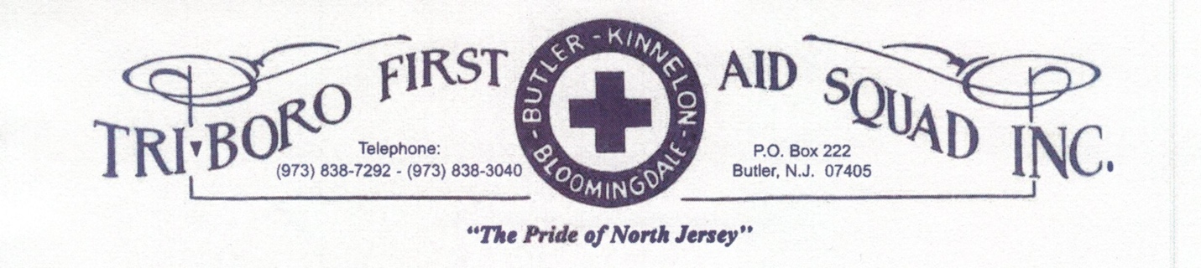

TBFAS Meeting Minutes
Date: January 10, 2022
Meeting was called to order at 19:37 by Gayle Dunlap, President with a salute to the flag followed by a moment of silence for Buzz Warren and Danny Canty. Roll call taken by Rania Amer. Motion to accept minutes by Mary Hall, seconded by Mike Johnston. .
Treasurer’s Report: Leslie Graf:
Beginning Balance: $125,845.73
Deposits: $30,570.00
Expenses: $22,182.82
January 1, 2022 Balance: $134,232.91
Fund Drive to Date: $63,795.00
Gold Cross: Dee Dunlap-Dean: this month’s meeting will be on zoom.
Health & Welfare: Leslie Graf: no report
Special Events: Patti Tabler: Hazel Whitty reported – we had to postpone the installation dinner again, we hope to have a small celebration and Dave Schimmel to perform the installation via zoom, catered by Boniellos at February’s Business meeting. The team talked about next year’s celebration and already started to canvas for different venues as we were used to before, getting pricing, availability, etc. We would also again invite 3 towns too. If anyone has any suggestions or questions let the committee know.
Loan Outs: Michael Johnston: getting more stuff that we will need to donate, we have enough of everything. Hazel brought some stuff from a veteran who passed and some things are expensive so she donated it in case someone could use them. We donated old jackets with badges removed to CARES to the group in Rockaway that did our Narcan training.
Teen Squad: Patti Tabler: smaller squad for this year, charter is being worked on, hopefully teens will ride in the summer.
By Laws: Linda McKnight: nothing at moment
Publicity: Buzz Warren: no report
Refreshments: Amanda LoCicero: no report
Uniforms: Alysha Hammaker: cutting off the badges off old jackets, keeping decent ones for proby members
Radios: John Futcher: has quote for new radios for rigs will bring up next month
I & G: Dean Dunlap Dean: no report
Oxygen: George Chernetz: no report
Membership: Dee Dunlap Dean: one person that’s taking EMT course in Bergen County in spring.

Building & Grounds: Dean Marletta: no report
Ways & Means: Patti Tabler: nothing going on, maybe fish dinner again, Applebees will be starting Flap Jack breakfast fundraiser soon.
Insurance: Skip Mullin: Gayle Dunlap reporting: met with Skip Mullin, he didn’t feel he has the authority to give insurance company information. Gayle Dunlap spoke to insurance company and that should be good now, he will next be looking at the life insurance to get new members signed up.
Health & Safety: George Chernetz: no report
Ad Hoc Tablets: Patti Tabler: delayed with the state administrator issue, will train members when we get closer to a date, system will be the same so we can train on the current system.
Ad Hoc Rig: Mary Hall: no report
Captain’s Report: John Futcher: 195 calls / 61 to MC, 134 were ours, we made 105 of them, missed 29 for a 78% coverage. Rigs in good shape, 37 went down to shop, monitor valve was bad for 02, needed new steering box. 1826 calls for the year that the pager went off. Email from Atlantic Health Care, free covid tests for first responders.
Patti Tabler: Can we fix the clocks in the rigs? People to wear watch for trip sheets for consistent times.
Lt’s Report: no report
Chief Instructor: Gayle Dunlap: Next week’s training will be blood borne pathogens. Some people need CPR renewal in February, we will be holding CPR training Monday 2/7 at 6:30 pm at the building.
President’s Report: Gayle Dunlap: Thanked Justin Hill for going over items with Gayle and thank you for your time serving the last few years. Rev. Hannah Lee from the Bloomingdale Methodist Church will be our new Chaplin, she is listed on phone list, if you need clergy on call, she will come out. Anish Kuriachen of the squad is also available for Clergy if Rev. Hannah Lee is unavailable.
There were some errors with the new member’s numbers, those members have been notified and the correct list is hanging on the door at the building and in each rig.
By laws state we need 7 trustees, we have six so Gayle Dunlap asked Jim Lampmann to be the 7th trustee.
Our Trustees include: the 3 Mayors, Ed Fletcher, Tommy Decker, Glen Sisco and Jim Lampmann
Evelyn Schubert, new councilwomen in Bloomingdale is the liaison to Tri-Boro.
Correspondence: Annette Vanderhoff: thank you sent to the Pellegrino Family for $1500.00 donation and note read. Thank you sent to Butler United Methodist Church for $540.00 donation and note read.
Absences: January 2022 Business Meeting: Skip Mullin, work; Helen Wyckoff, icy roads; George Chernetz, work; Deborah Keller, work. January 2022 Education Meeting: George Chernetz, work; Deborah Keller, work.
Presentation of Bills: Leslie Graf: motion to accept bills for payment made by Steve Widmer, seconded by Hazel Whitty, motion carried.
Old Business:
Justin Hill questioned giving the gift to the cleaning lady at Christmas vs. donating to a fundraiser like a golf outing. Discussion was had, Linda McKnight had received a legal opinion on that a while ago and TBFAS cannot legally donate to another charity because we raise funds for our squad as a 501(C)3 charity. Justin will bring back to table at the end of the year.

New Business:
Dean Marletta: asking where we get the tourniquet bags, John Futcher stated they are MC property and we need to replace whatever is used or expired. Dean Marletta stated that they used a lot of combat gauze on a call, so we will need to replace the gauze.
Gayle Dunlap - we received a notice from Stryker, their prices are going up, all prices are in our contract so this would only affect us with the stair chair not the cots.
Motion to adjourn made by Steve Widmer, seconded by Dean Dunlap-Dean, motion carried.
Respectfully submitted,
Annette Vanderhoff, EMR
Squad Secretary

